**DAILY ONLINE ACTIVITIES SUMMARY**

|  |  |  |  |  |  |  |  |  |
| --- | --- | --- | --- | --- | --- | --- | --- | --- |
| **Date:** | **31-07-2020** | | | | | **Name:** | **Kanaka BS** | |
| **Sem & Sec** | **6th & A** | | | | | **USN:** | **4al17cs039** | |
| **Online Test Summary** | | | | | | | | |
| **Subject** | | **-** | | | | | | |
| **Max. Marks** | | **-** | | **Score** | | | **-** | |
| **Certification Course Summary** | | | | | | | | |
| **Course** | **HTML CSS and JavaScript for web developers** | | | | | | | |
| **Certificate Provider** | | | **Coursera** | | **Duration** | | | **5 Weeks** |
| **Coding Challenges** | | | | | | | | |
| **Problem Statement**: **Python Program for focal length of a spherical mirror** | | | | | | | | |
| **Status: Solved** | | | | | | | | |
| **Uploaded the report in Github** | | | | | **yes** | | | |
| **If yes Repository name** | | | | | <https://github.com/kanakabs/Daily-Status> | | | |
| **Uploaded the report in slack** | | | | | **yes** | | | |

**ONLINE COURSE**

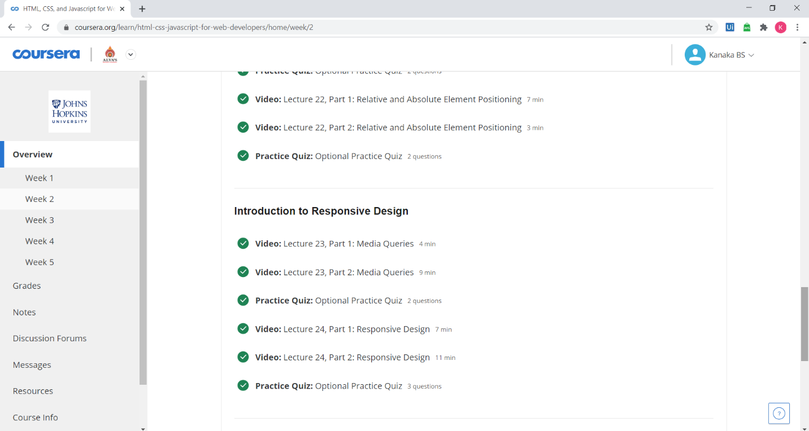

**ONLINE** **CODING**

**Python Program for focal length of a spherical mirror**

def focal_length_concave(R):

return R / 2

def focal_length_convex(R):

return - ( R/ 2 )

R = 50

print ("Focal length of spherical concave mirror is :", focal_length_concave(R)," units")

print ("Focal length of spherical convex mirror is : ", focal_length_convex(R)," units")

